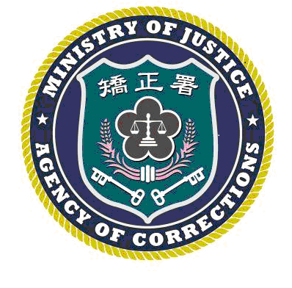 | LYUDAO PRISON PRESS, AGENCY OF CORRECTIONS, MINISTRY OF JUSTICE  RELEASE DATE: April 14,, 2025  Contact：Chen Chi-mao (陳琦茂)  Phone：(089)672502#111 Number:114002

BEACH CLEANUP TRANSFORMED INTO "ANTI-FRAUD BEACH PARTY"!
LYUDAO PRISON COUNSEL USES HUMOR AND HEART TO COMBAT SCAMS
TAITUNG, Taiwan – April 14, 2025 What began as a simple beach cleanup turned into an unexpected "Anti-Fraud Stand-up Comedy"! During a beach cleanup event organized by Chung-Hsin Electric and Machinery Mfg. Corp. on April 11, Lyudao Prison not only helped restore the shoreline but also brought anti-fraud awareness to the sandy stage.
The keynote speaker, Counsel Su Yan-teng (蘇彥騰), displayed his "comedic soul" by sharing a series of both absurd and tragic scam cases. He reminded the audience: "There’s no such thing as a free lunch, let alone 'dream lunches' like free iPhones or investments that tenfold in three days!" His performance was met with waves of laughter and applause.
A special highlight was the participation of teachers and students from Lyudao Elementary and Junior High Schools. Counsel Su Yan-teng (蘇彥騰) earnestly cautioned the youth: "Never let curiosity turn you into an assistant for fraud syndicates, acting as someone else's 'ATM' or 'caller robot'! Earn your money honestly and don't get on the wrong boat—otherwise, you won't make money, and your 'room' might be upgraded to a prison ward!"
This "Cleanup + Mental Detox" event not only cleaned the coast but also significantly boosted the public’s immunity against fraud. Moving forward, Lyudao Prison will continue to use creative outreach to make "anti-fraud" a life skill for all citizens.
###

