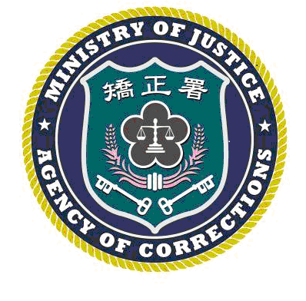 | LYUDAO PRISON PRESS, AGENCY OF CORRECTIONS, MINISTRY OF JUSTICE  RELEASE DATE: MAY 15, 2025  Contact：Chen Chi-mao (陳琦茂)  Phone：(089)672502#111 Number:114003

LEGISLATIVE YUAN JUDICIARY AND LEGAL AFFAIRS COMMITTEE INSPECTS INDIVIDUALIZED TREATMENT FOR INMATES AT LYUDAO PRISON
TAITUNG, Taiwan – May 15, 2025 On the afternoon of May 15, 2025, the Legislative Yuan Judiciary and Legal Affairs Committee, led by Convener Chuang Jui-hsiung (莊瑞雄) and accompanied by Legislator Lin Chien-chi (林倩綺), conducted an on-site inspection of Lyudao Prison. The delegation included Su Chun-jung (蘇俊榮), Director-General of the Directorate-General of Personnel Administration; Huang Shih-chieh (黃世杰), Deputy Minister of Justice; and Lin Ming-ta (林明達), Deputy Director-General of the Agency of Corrections. The group inspected the prison’s operations, listened to an official briefing, and participated in a symposium.

During the inspection, Superintendent Lyu Hsien-tzu (呂憲慈) provided a briefing covering the prison's overall operations, current business status, institutional characteristics, and future key objectives. The presentation focused specifically on the implementation and effectiveness of the Individualized Treatment policy for inmates.

Convener Chuang Jui-hsiung (莊瑞雄) expressed his commendation for Lyudao Prison’s proactive efforts in various operations. He instructed the staff to continue strengthening the connection between inmates and their families, utilizing family support to help inmates successfully reintegrate into society. He also emphasized that human rights concepts must be continuously implemented in inmate management and that treatment measures should be further refined. Regarding the hard work of correctional staff on night shifts, he stated he would assist in advocating for the "Midnight Danger Pay." Additionally, Legislator Lin Chien-chi (林倩綺) expressed concern regarding inmate medical issues and reminded the administration to provide proper medical care and attention to inmates suffering from mental illnesses.

