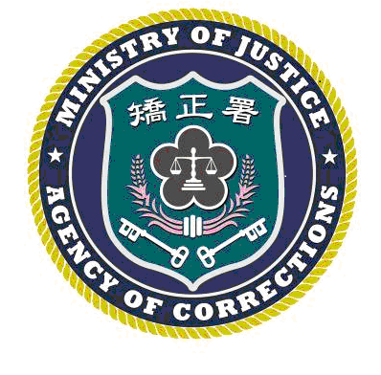 | LYUDAO PRISON PRESS, AGENCY OF CORRECTIONS, MINISTRY OF JUSTICE  RELEASE DATE: MAY 29, 2025  Contact：Chen Chi-mao (陳琦茂)  Phone：(089)672502#111 Number:114004

LEARNING FROM "THE UPSIDE": LYUDAO PRISON CONDUCTS WORKPLACE BULLYING PREVENTION SEMINAR
TAITUNG, Taiwan – May 29, 2025 To enhance staff awareness and sensitivity regarding workplace bullying, Lyudao Prison, Agency of Corrections, Ministry of Justice, integrated a "Workplace Bullying Prevention Seminar" into its staff birthday celebration on May 28, 2025. The seminar was delivered by Counsel Su Yan-teng (蘇彥騰), who provided a clear and profound explanation of the diverse manifestations of bullying behaviors through relevant legal regulations and practical case studies.

Counsel Su Yan-teng (蘇彥騰) pointed out that workplace bullying refers to the abuse of power or unfair punishment in the workplace or during the performance of duties, which results in persistent offense, threats, cold treatment, isolation, or insulting behaviors. These actions cause the victim to feel frustrated, threatened, humiliated, isolated, and injured, thereby undermining their self-confidence and bringing heavy physical and mental stress. He further explained that workplace bullying is not limited to intense physical or verbal conflicts and public humiliation; continuous sarcasm, deliberate ignoring, or social exclusion also constitute forms of bullying. He reminded the staff to be mindful of and avoid bringing harm to colleagues through unintended words or actions.

The event featured a screening of the drama film The Upside, which depicts how two main characters with completely different personalities influence each other, release their emotions, and gradually change while facing life's adversities. The film addresses the issue of unequal power dynamics in the workplace, showing how a caregiver and a care recipient experience conflict, compromise, and negotiation to ultimately achieve a balance in their relationship and affirm their self-worth. Lyudao Prison utilized this film as a medium to encourage staff to exchange insights, thereby deepening their understanding of and resonance with the seminar's theme.

At the conclusion of the seminar, Superintendent Lyu Hsien-tzu (呂憲慈) emphasized that every staff member is a shaper of workplace culture. Serving together in the same institution means everyone should cherish one another and maintain mutual respect. He encouraged all staff to work together to build a warm and healthy professional environment.

